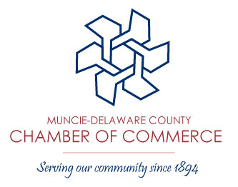

Committees/Meetings Supported by the
Chamber of Commerce

Ambassador Council
The council comprises Chamber members who promote membership and encourage participation in Chamber functions, assist with events & programs, and perform other goodwill projects of the Chamber. Participation is by application only.
Contact: Erin Ailstock
Meet: Second Tuesday bi-monthly at 4:00pm, beginning in January
Location: Chamber of Commerce Boardroom

Business/Education Partnership
Liaison between the educators, business and labor communities as well as helping foster an environment of continued learning within our community.
Contact: Brenda Brumfield
Meet: Last Friday each month @7:30am
Location: Chamber of Commerce Boardroom

Business Growth Council
The committee comprises a cross section of business interests in Delaware County. The group focuses on legislative matters and other issues impacting local business.
Contact: Brenda Brumfield
Meet: Forth Monday of each month @4:00pm
Location: First Merchants Bank, Downtown Location

Chamber of Commerce Board of Directors
The Board of Directors is the governing body of the Chamber of Commerce.
Contact: Jay Julian
Meet: Third Tuesday of each month @3:30pm
Location: Chamber of Commerce Boardroom

Economic Development
Economic Development staff and local business leaders meet to discuss current economic development projects, followed by a roundtable discussion of issues and opportunities facing various business sectors.
Contact: Terry Murphy
Meet: Fourth Thursday every-other month @3:30pm beginning in January
Location: Chamber of Commerce Boardroom

Committees/Meetings Supported by the Chamber of Commerce (Cont’d)

Government Relations
Advocates a pro-active role in local, state, and national public policy issues, educating members and the community on all levels of legislative issues along with enhancing communications with elected officials.
Contact: Brenda Brumfield
Meet: Second Thursday of each month @7:30am
Location: Chamber of Commerce Boardroom

Image Committee
In the process of creating and implementing a campaign to enhance the Muncie’s self-image. This committee is working in conjunction with Muncie Action Plan to execute MAP’s Initiative 3: Strengthening, Pride and Image.
Contact: Brittany Collins & Traci Lutton
Meet: Second Wednesday of each month @4:00pm
Location: Chamber of Commerce Boardroom

